8.9- Graphing Rational Functions Notes (Day 4)

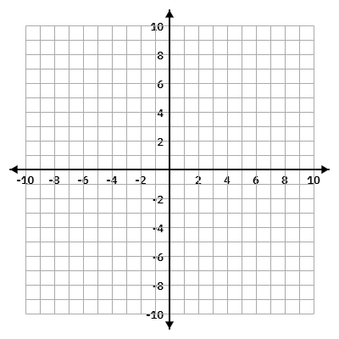
Graph the following and provide all required information.

1. $f(x)=\frac{4x+2}{x-2}$
Domain: ______________________

VA: __________ HA: ___________

Holes: _______________________

Range: ______________________

x-int: __________ y-int: _________

Asymptotic Behavior:


2. $f(x)=\frac{5x+20}{x^{2}+3x-4}$
Domain: ______________________

VA: __________ HA: ___________

Holes: _______________________

Range: ______________________

x-int: __________ y-int: _________

Asymptotic Behavior:

